PROJECT SPECIFICATION

Kidnapped Vehicle
Accuracy

CRITERIA | MEET SPECIFICATIONS
Does your particle filter localize the vehicle to within the desired accuracy ? | Output says "Success! Your particle filter passed!" (Screenshot as below)
Output screenshots

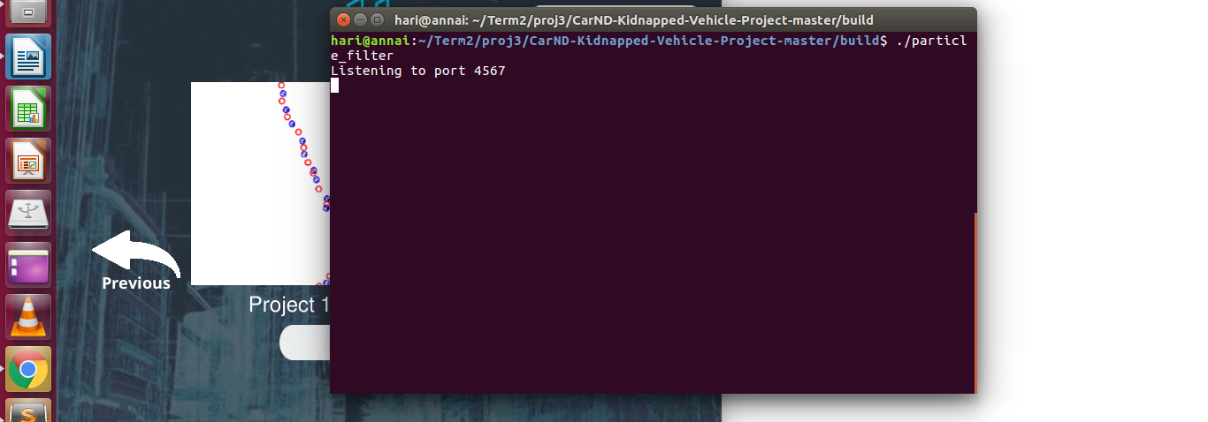
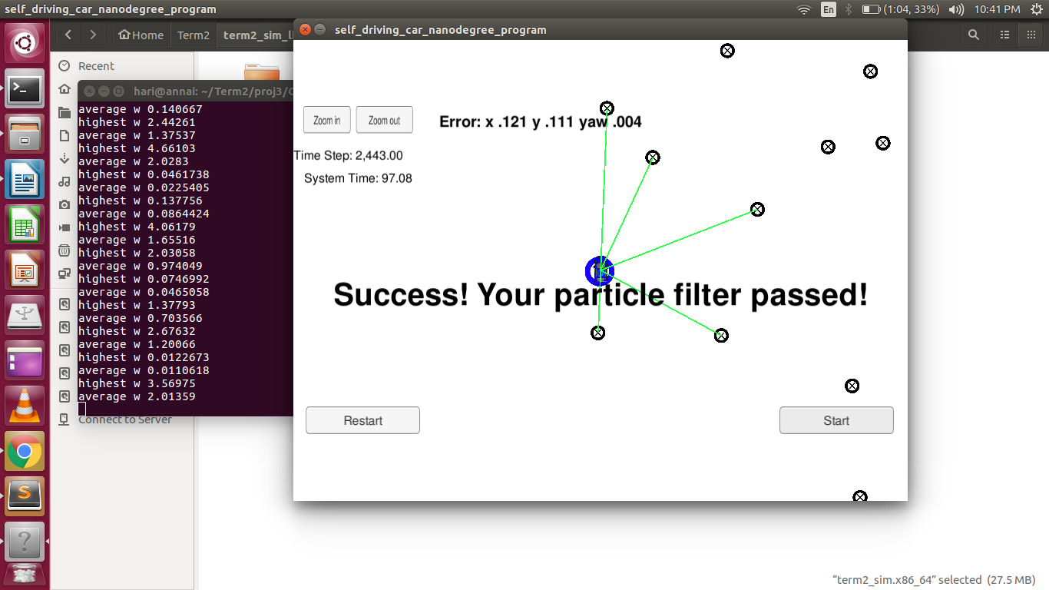

Performance

CRITERIA | MEET SPECIFICATIONS
Does your particle run within the specified time of 100 seconds? | Output arrived by 97.08 seconds (As shown above in the screen shot)

General

CRITERIA | MEET SPECIFICATIONS
Does your code use a particle filter to localize the robot? | Error for x .121 y .111 yaw .004 achieved.  particle_filter.cpp file submitted

